**DAILY ONLINE ACTIVITIES SUMMARY**

|  |  |  |  |  |  |  |  |  |
| --- | --- | --- | --- | --- | --- | --- | --- | --- |
| **Date:** | **26-05-2020** | | | | | **Name:** | **Anusha** | |
| **Sem & Sec** | **8th sem, A sec** | | | | | **USN:** | **4AL16CS014** | |
| **Online Test Summary** | | | | | | | | |
| **Subject** | | **Big Data Analytics** | | | | | | |
| **Max. Marks** | | **Test 1: 20**  **Test 2: 20** | | **Score** | | | **Test 1: 16**  **Test 2: 14** | |
| **Certification Course Summary** | | | | | | | | |
| **Course** | **Introduction to Hadoop** | | | | | | | |
| **Certificate Provider** | | | **Great Learning Academy** | | **Duration** | | | 4 hour |
| **Coding Challenges** | | | | | | | | |
| **Problem Statement:** Write a program in C to print all permutations of a given string using pointers.   |  | | --- | |  | | | | | | | | | |
| **Status:Solved** | | | | | | | | |
| **Uploaded the report in Github** | | | | | **Yes** | | | |
| **If yes Repository name** | | | | | **anushasuvarna-014** | | | |
| **Uploaded the report in slack** | | | | | **Yes** | | | |

Online test details:

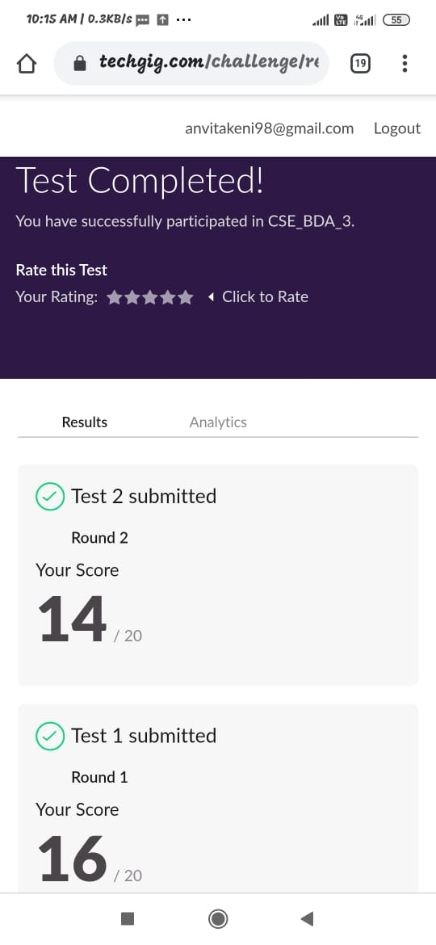

Certification Course Details:

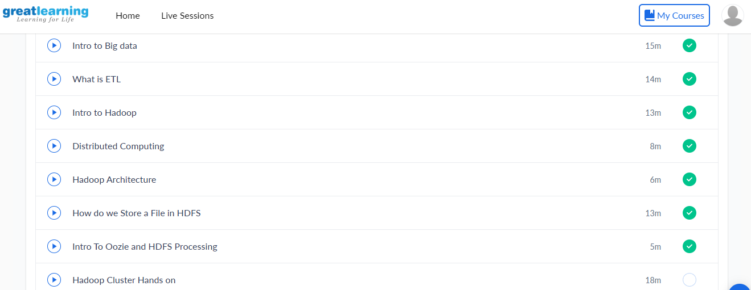

Introduction to Oozie & HDFS processing:

Apache Oozie is a tool which comes while installation of Hadoop. It is used to schedule the program. In the Hadoop eco system we are invoking the java object. Objects will get all these metadata and give it to clients. Clients can keep it in memory and then read one by one.

Online coding Details:

Write a program in C to print all permutations of a given string using pointers.

|  |
| --- |
|  |

#include <stdio.h>  
#include <string.h>

/* Function to swap values at two pointers */  
void swap (char *x, char *y)  
{  
char temp;  
temp = *x;  
*x = *y;  
y = temp;}/ End of swap() */

/* Function to print permutations of string */  
void permute(char *a, int i, int n)  
{  
int j;  
if (i == n)  
printf("%s\n", a);  
else {  
for (j = i; j <= n; j++)  
{  
swap((a + i), (a + j));  
permute(a, i + 1, n);  
swap((a + i), (a + j)); //backtrack  
}  
}  
}

/* The main() begins */  
int main()  
{  
char a[20];  
int n;  
printf("Enter a string: ");  
scanf("%s", a);  
n = strlen(a);  
printf("Permutaions:\n");  
permute(a, 0, n - 1);  
getchar();  
return 0;  
}